**Phase 4: Process Automation (Admin)**

**1.Validation rule:**

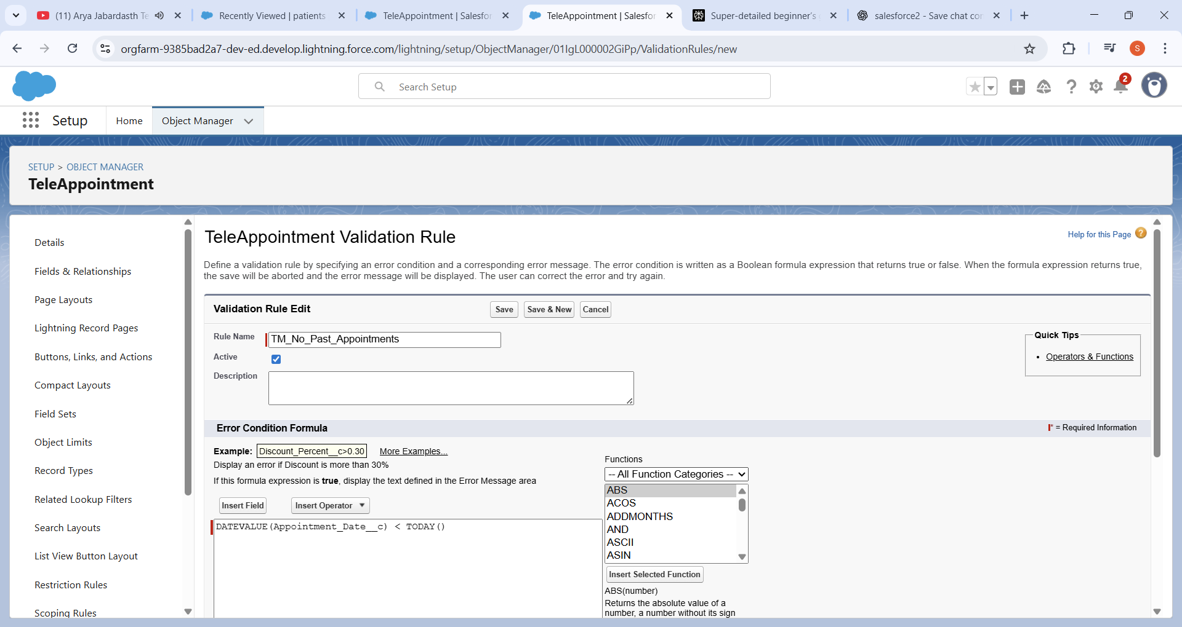

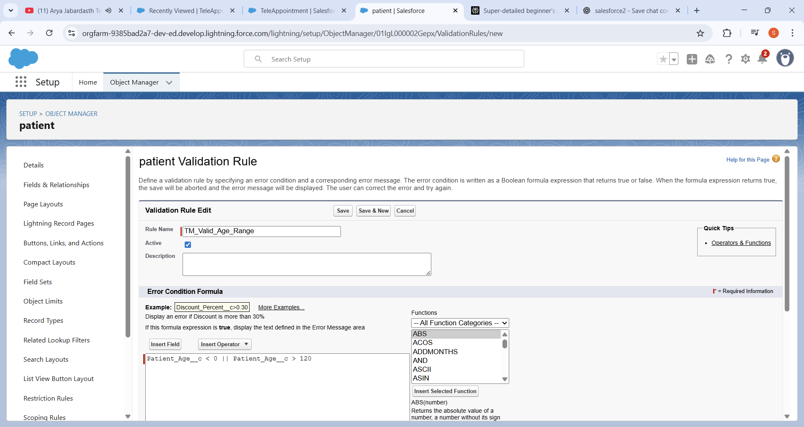

**Validation Rules**

A validation rule is a simple way to **prevent bad data from being saved**. It checks a record before it's saved and, if the rule is true, it displays an error message.

* **TM_No_Past_Appointments**: This rule prevents a user from creating a TeleAppointment with a date that is in the past. It uses the formula

DATEVALUE(Appointment_Date__c) < TODAY().

* **TM_Valid_Age_Range**: This rule ensures a Patient's age is within a valid range. It uses the formula Patient_Age__c < 0 || Patient_Age__c > 120.

**2.Lightning Email Template:**

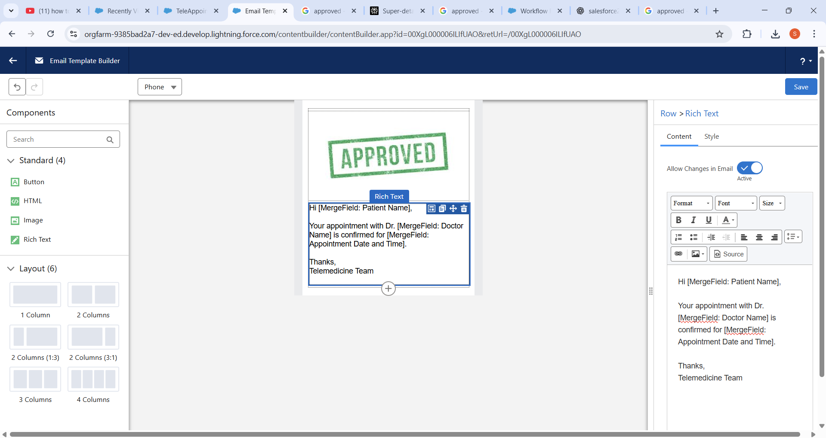

The email template is created with the above structure.

The email that gets sent uses a

**Lightning Email Template**, which includes an "APPROVED" stamp and merge fields for the Patient Name, Doctor Name, and Appointment Date and Time.

**4.Workflow Rules Validation:**

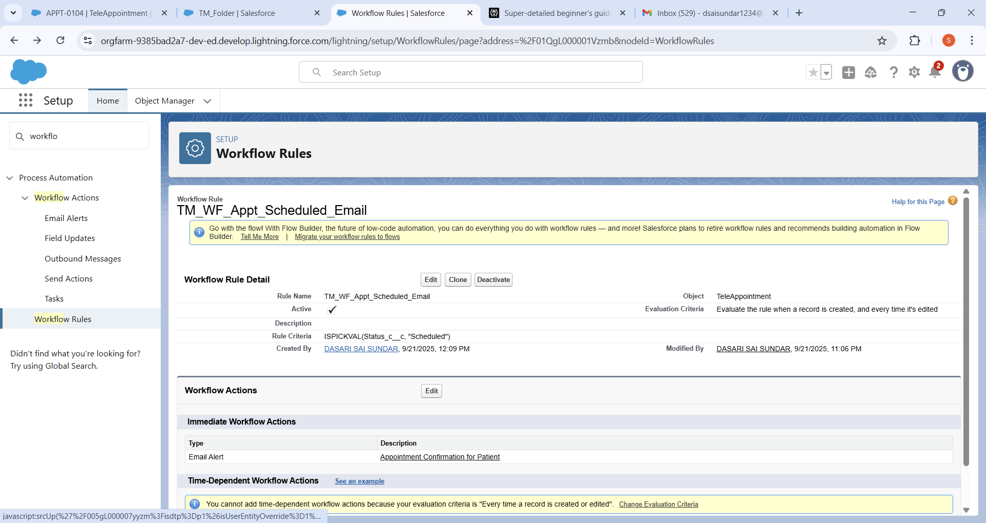

Created The TM_WF_Appt_Scheduled_Email

A Workflow Rule is a tool that performs an action when a record meets a specific criteria.

* TM_WF_Appt_Scheduled_Email: This rule automatically sends an email to the patient when a TeleAppointment's status is set to "Scheduled."
* The email that gets sent uses a

Lightning Email Template which includes an "APPROVED" stamp and merge fields for the Patient Name, Doctor Name, and Appointment Date and Time.

**6.Process Builder:**

In TeleAppointment Object when we select speciality we can get assigned the doctor according to the specialization.

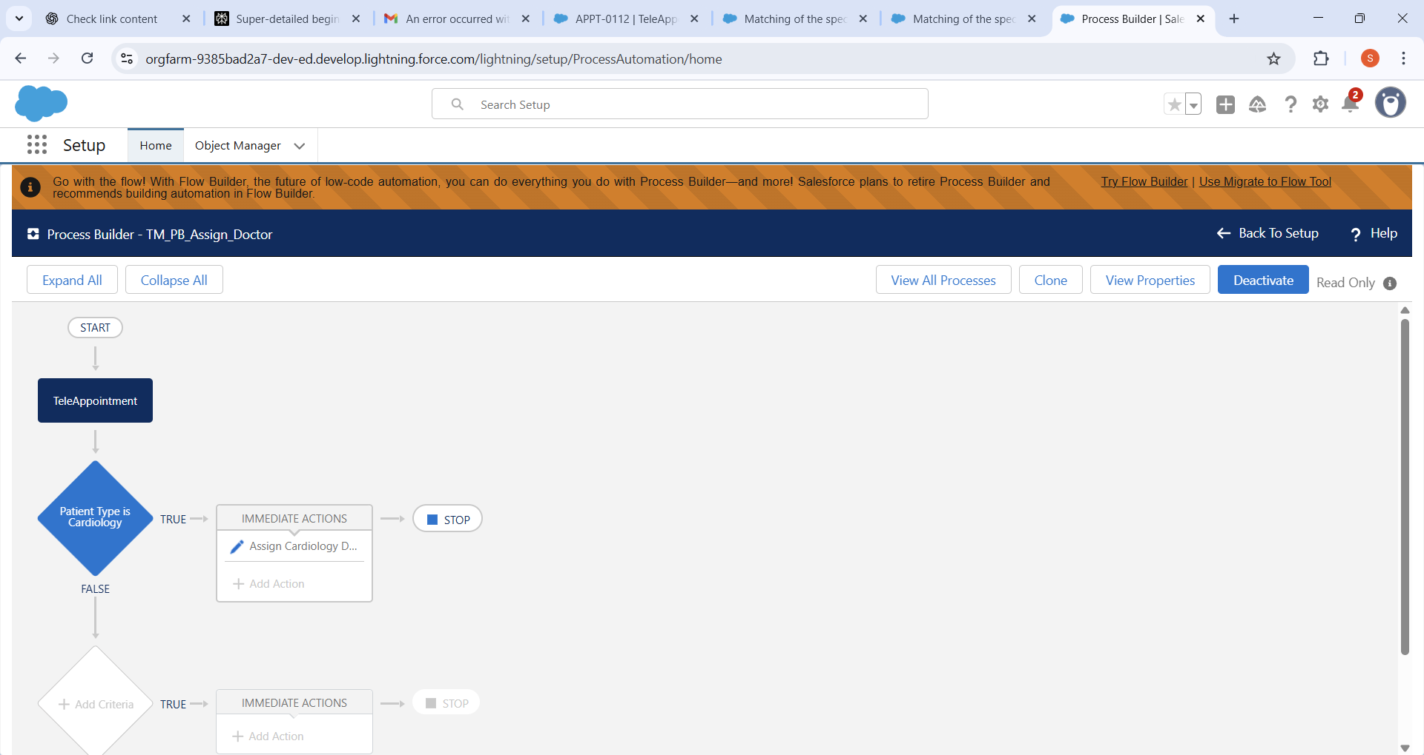

Here for the cardiology assigned doctor can be allocated.

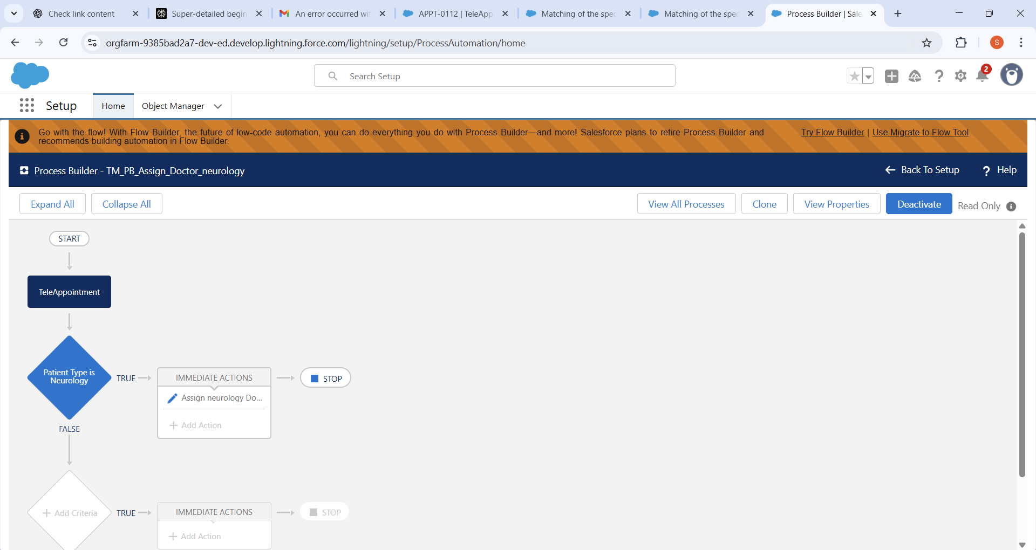

Here for the cardiology assigned doctor can be allocated.

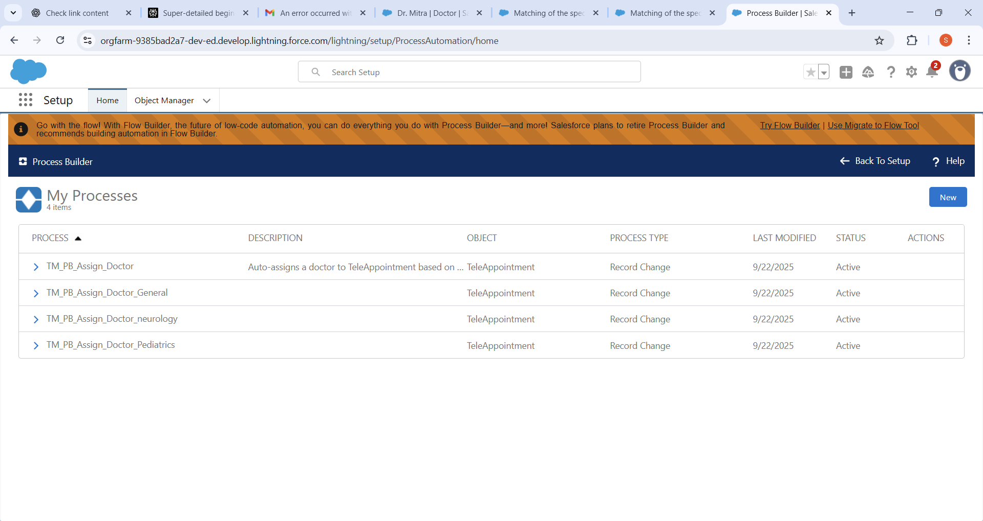

Same as the General and Pediatrics doctor can be allocated accordingly.

**Process Builder** is a powerful tool for automating business processes using a visual interface. It works by checking criteria and then performing immediate actions.

* **Assigning a Doctor**: You have created a Process Builder that automatically assigns a doctor to a TeleAppointment record based on the patient's selected specialty.
* For example, if the

Patient Type is 'Cardiology', a specific Cardiology doctor is assigned. Similarly, doctors are allocated for 'Neurology', 'General', and 'Pediatrics' specialties.

**7.Approval Process:**

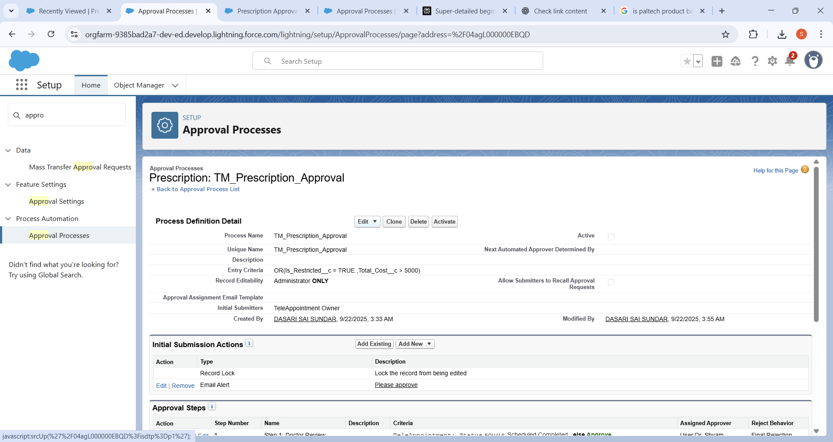

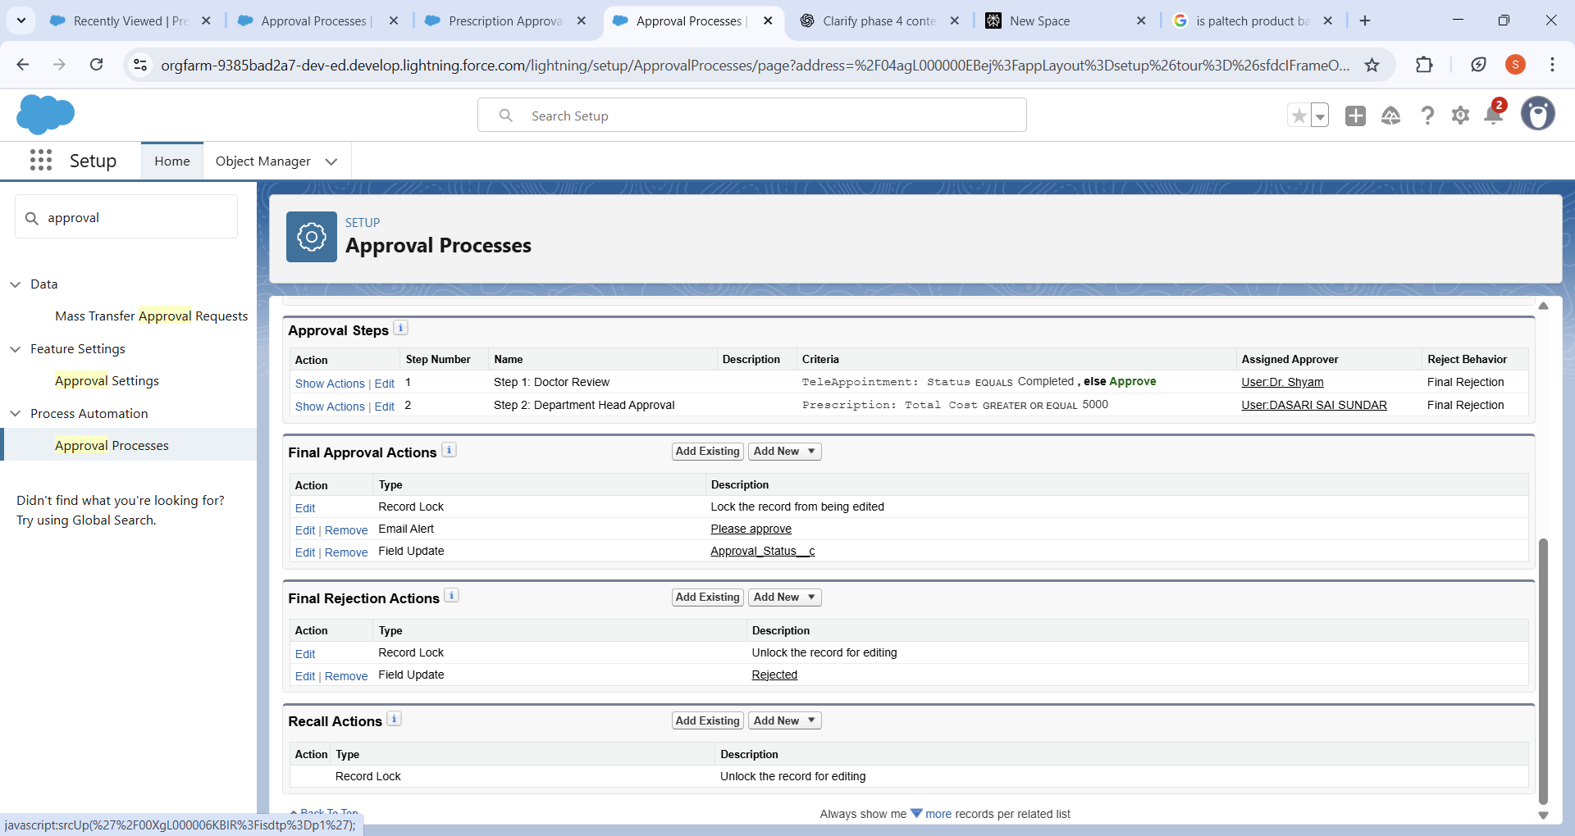

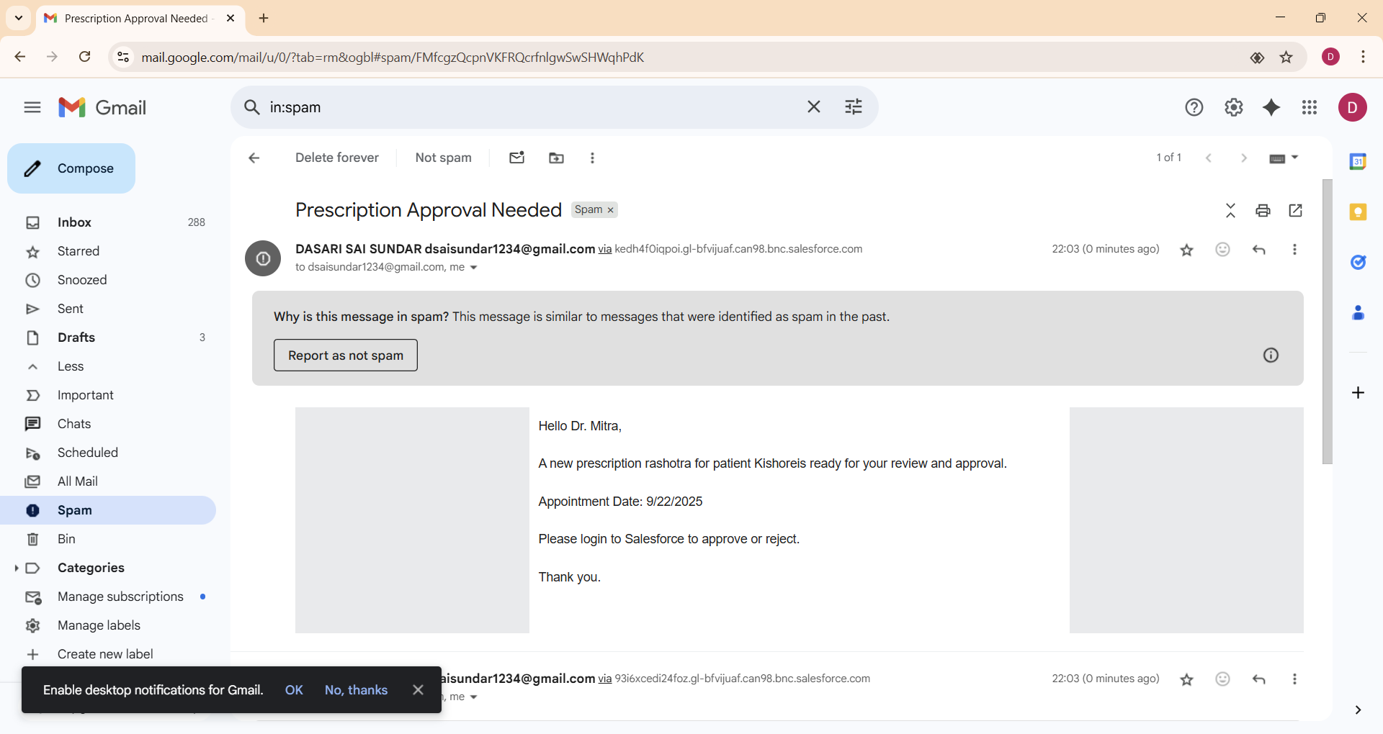

**Approval Process**

An Approval Process is used when you need to get formal permission before a record is finalized.

* **TM_Prescription_Approval**: This process is for approving prescriptions. It's triggered when a prescription is restricted or the total cost is over $5,000.
* The approval process has two steps: a "Doctor Review" and a "Department Head Approval."
* When a record is submitted for approval, an email is sent to the assigned approvers to notify them.

**8.Flows:**

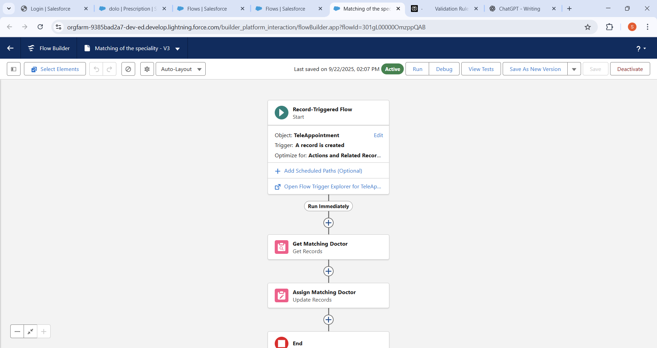

Flow is a visual automation tool that can perform everything a Process Builder or Workflow Rule can, and much more.

* You have a

Record-Triggered Flow on the TeleAppointment object that runs when a new record is created.

* This Flow gets a matching doctor record from the database and assigns them to the appointment, which is a modern way to perform the same task as your Process Builder.